**Tejas Chopda**

**Survey Report on Types of Blockchains and it’s real time use cases**

**BlockChains:** Blockchain can be deﬁned as an immutable distributed digital ledger, which is secured using advanced cryptography, replicated among the peer nodes in the peer-to-peer network, and uses consensus mechanism to agree upon the transaction log, whereas control is decentralized. It provides data integrity with a single source of truth, eliminating data duplication and increasing security. In a blockchain system, fraud and data tampering are prevented because data can’t be altered without the permission of a quorum of the parties. A blockchain ledger can be shared, but not altered. If someone tries to alter data, all participants will be alerted and will know who make the attempt.

The ﬁrst successful cryptocurrency and blockchain application was released in 2009, combining concepts of public key cryptography with a consensus algorithm known as proof-of-work. Blockchain concept was introduced with the Bitcoin white-paper to solve the double-spending problem, when executing a transaction over a communication medium without relying on a trusted third party like a ﬁnancial institution or a bank.

**Types of blockchain**

1. Public blockchain :

A public, or permission-less, blockchain network is one where anyone can participate without restrictions. Most types of cryptocurrencies run on a public blockchain that is governed by rules or consensus algorithms. This user can access current and past records and conduct mining activities, the complex computations used to verify transactions and add them to the ledger. No valid record or transaction can be changed on the network, and anyone can verify the transactions, find bugs or propose changes because the source code is usually open source.

1. Private blockchain :

A private, or permissioned, blockchain allows organizations to set controls on who can access blockchain data. Only users who are granted permissions can access specific sets of data. Oracle Blockchain Platform is a permissioned blockchain. A blockchain network that works in a restrictive environment like a closed network, or that is under the control of a single entity

### Hybrid blockchain :

A type of blockchain technology that combines elements of both private and public blockchain. It lets organizations set up a private, permission-based system alongside a public permissionless system, allowing them to control who can access specific data stored in the blockchain, and what data will be opened up publicly.

Typically, transactions and records in a hybrid blockchain are not made public but can be verified when needed, such as by allowing access through a [smart contract](https://searchcompliance.techtarget.com/definition/smart-contract). Confidential information is kept inside the network but is still verifiable.

1. Consortium blockchain.

Blockchain network where the consensus process (mining process) is closely controlled by a preselected set of nodes or by a preselected number of stakeholders. Also known as a federated blockchain, is similar to a hybrid blockchain in that it has private and public blockchain features. But it's different in that multiple organizational members collaborate on a decentralized network. Essentially, a consortium blockchain is a private blockchain with limited access to a particular group, eliminating the risks that come with just one entity controlling the network on a private blockchain.

In a consortium blockchain, the consensus procedures are controlled by preset nodes. It has a validator node that initiates, receives and validates transactions. Member nodes can receive or initiate transactions.

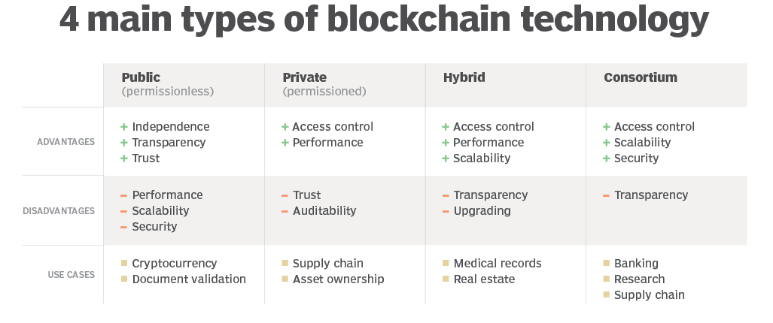

Blockchain technology’s core characteristics include decentralization, transparency, immutability, and automation. These elements can be applied to various industries, creating a multitude of use cases.

**[Supply Chain Management](https://consensys.net/blockchain-use-cases/supply-chain-management/" \o "" \t "_self)**

**Private Blockchain,** Existing global supply chains are inefficient, poorly tracked, and oftentimes exploitative. Blockchain can facilitate accurate asset tracking, enhanced licensing of services, products, and software, and transparency into the provenance of consumer goods, from sourcing to the point of consumption.

**[Real Estate](https://consensys.net/blockchain-use-cases/real-estate/" \o "" \t "_self)**

**Hybrid Blockchain,** Enterprise Ethereum enables the digitization of assets and financial instruments. This enhances fractionalization of ownership, expanded access to global markets, increased liquidity, and democratized access to real estate investment opportunities.

**[Sports and Esports](https://consensys.net/blockchain-use-cases/sports-and-esports/" \o "" \t "_self)**

Ethereum enabled smart contracts can streamline existing esports operations, provide new revenue models, and enhance fan engagement with enhanced loyalty programs and incentives.

**[Law](https://consensys.net/blockchain-use-cases/law/" \o "" \t "_self)**

An institutional-grade blockchain solution can address the estimated 9.8% loss in total productivity that manual operations costs a law firm every year by providing accessibility, transparency, cost savings, speed, efficiency, and data integrity.

**[Government and the Public Sector](https://consensys.net/blockchain-use-cases/government-and-the-public-sector/" \o "" \t "_self)**

Ethereum blockchain technology allows governments to build trust, improve accountability and responsiveness, increase efficiency, reduce costs, and create high-performing government functions with more secure, agile, and cost-effective structures.

**[Central Bank Digital Currencies](https://consensys.net/blockchain-use-cases/payments-and-money/cbdc/" \o "" \t "_self)**

CBDCs are a digital form of central bank money that offers central banks unique advantages at the retail and wholesale levels, including increased financial access for individual customers and a more efficient infrastructure for interbank settlements.